**Making changes in commits**

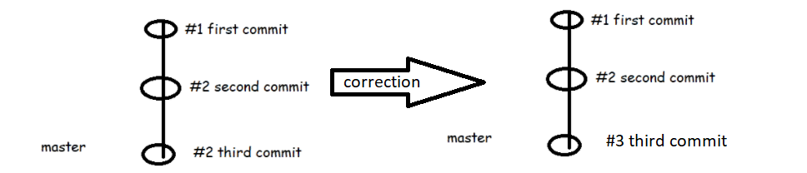

If it’s last commit, then> git --amend -m “correcting data’

* Changing the commit message of the immediate commit which head is looking at
* Change the commit messages way back in history
  + Now let’s use the pattern #0001 from #1 i.e. single digit to four digits

Git rebase interactive: git rebase -i head-position

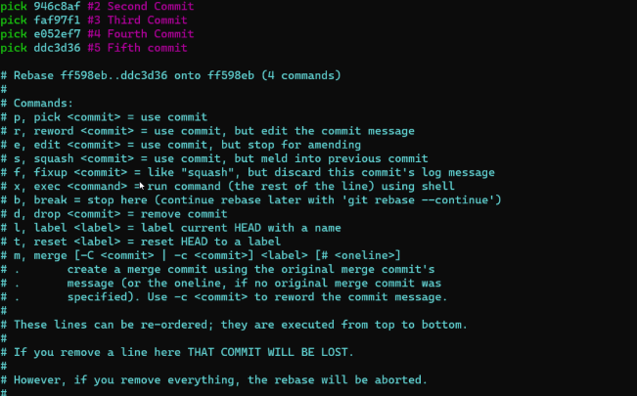

* git rebase -i --root
* git rebase -i HEAD~2
* Delete the commit in the history. Lets delete the second commit

git rebase -i HEAD~4

drop commit 2

Combining two commits into one commit > Here we use squash option

git rebase -i HEAD~2

pick third commit

squash fourth commit

pick fifth commit

Understanding head position

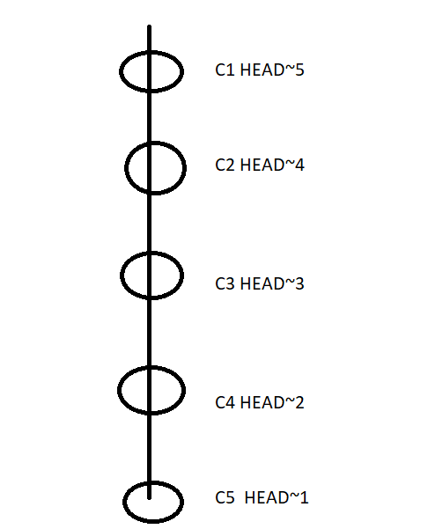

**Working with Remote Repository**

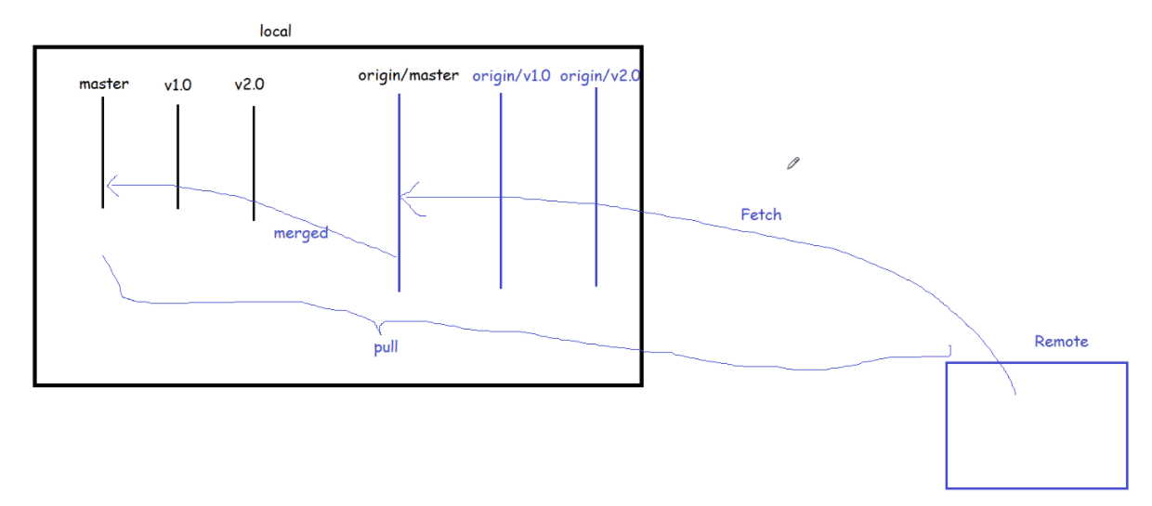

### **Connect it to GitHub**

* You’ve now got a local git repository. You can use git locally, like that, if you want. But if you want the thing to have a home on github, do the following.
* Log in to your account.
* Click the [new repository](https://github.com/new) button in the top-right. You’ll have an option there to initialize the repository with a README file, but I don’t.
* Click the “Create repository” button.

Now, follow the second set of instructions, “Push an existing repository…” $ git remote add origin [git@github.com:username/new_repo](mailto:git@github.com:username/new_repo) $ git push -u origin master

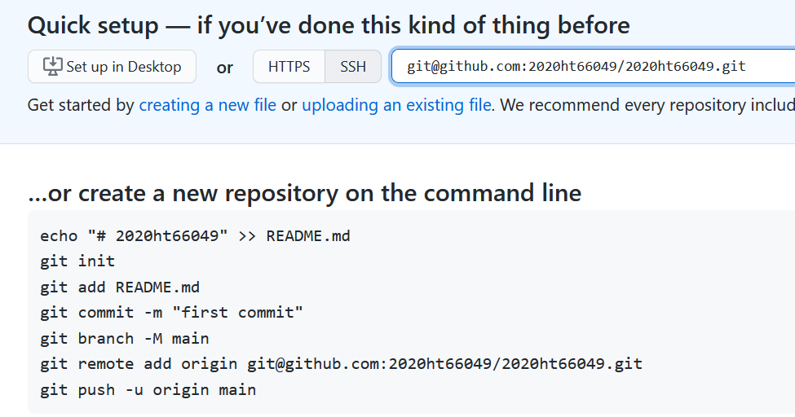

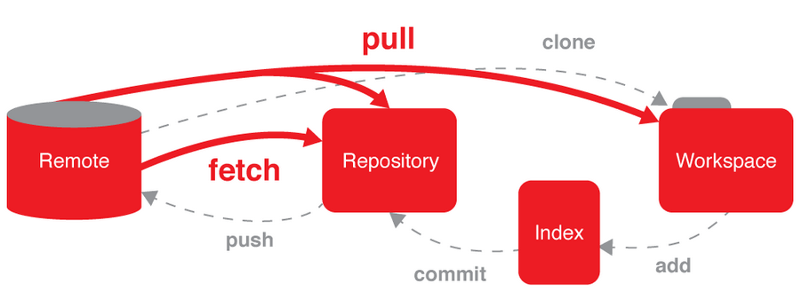

Pull mean bringing changes into local working directory, fetching means bringing changes into local repository.